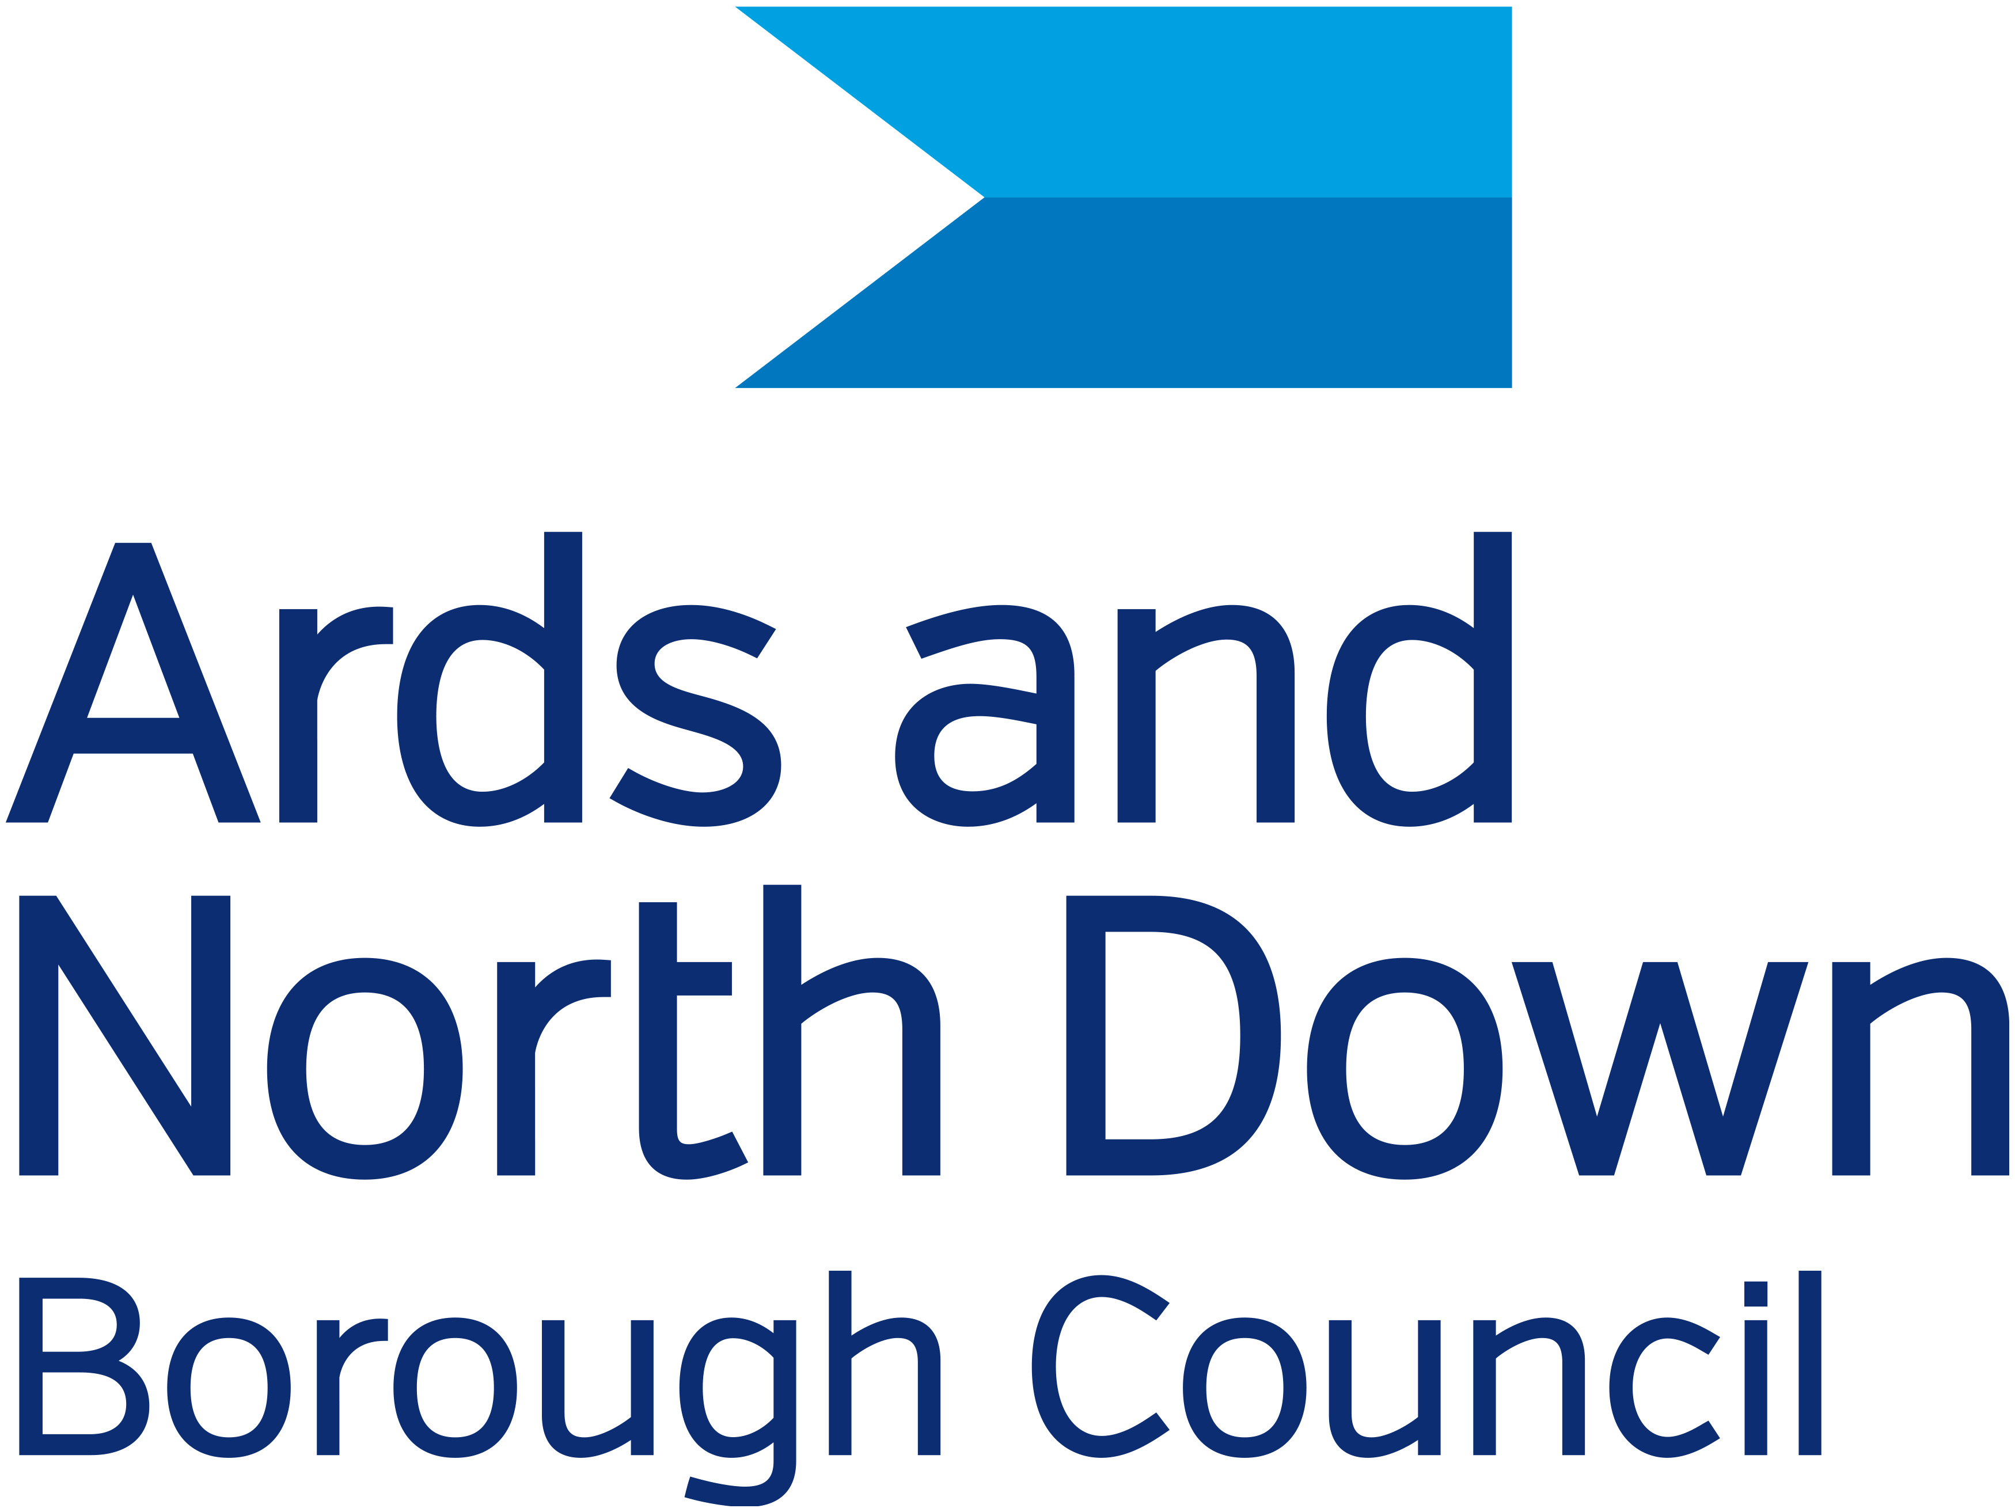

Ards and North Down Borough Council

Heritage Project Funding Application Form 25/26

Current Deadline for application:

Tuesday 13 May at 12 noon.

*Funding subject to budget approval*

Please read the guidance notes carefully before completing this form and remember to keep a copy of the completed application form for your own records.

Completed applications should be returned by post/hand delivered by the closing date of Tuesday 13 May at 12noon along with the required documentation to:

Ards and North Down Borough Council Museum Service

at heritagegrants@ardsandnorthdown.gov.uk

or by post:

North Down Museum
Town Hall
Bangor
BT20 4BT

Please write on your envelope: Heritage Project Grant Application

In order to protect your personal data, we would advise that all email grant return applications be encrypted:

Instructions for file encryption:

For Word:

1. Go to File > Info > Protect Document > Encrypt with Password.

2. Type a password, then type it again to confirm it.

3. Save the file to make sure the password takes effect.

For Mac:

1. On the Word menu, click Preferences.

2. Under Personal Settings, click Security Preferences button.

3. In the Password to open box, type a password, and then click OK.

4. In the Confirm Password dialog box, type the password again, and then click OK.

5. Click Save alternate text.

In order to communicate the password to a member of staff, please call (Tues to Fri 10am – 4pm) North Down Museum:

028 9127 1200

SECTION 1 – ABOUT YOUR GROUP

Name of Organisation (This should be the same as the name on your constitution)
______________________________________________________________

Address of Organisation __________________________________________

______________________________________________________________

City/town ________________________ Post Code _____________________

Name of contact person __________________________________________

Contact Person’s address _________________________________________

______________________________________________________________

City/town ________________________ Post Code _____________________

Daytime Tel: _____________________ Evening Tel____________________

E-mail _______________________________

In what year was your organisation started?

What type of organisation are you? (√)
If you are a company AND a recognised charity, please tick both boxes

Unincorporated club or association
Company limited by guarantee
Company limited by shares
Recognised charity
Trust
Other: Please specify
_____________________________

Recognised Charity Number (if applicable) ________________________

VAT Registration Number (if applicable) ________________________

Does your organisation have either a Constitution or a Memorandum and Articles of Association? (required)

Yes ◻ No □ If so, please attach a signed copy.

Does your organisation require Safeguarding (Child Protection) policies and procedures?

Yes ◻ No □ If so, please attach a copy.

What are the main aims of your organisation?

What are the current activities of your organisation?

What geographical area is covered by your organisation/project?

________________________________________________________

SECTION 2 – PROJECT DESCRIPTION

Title of project for which you are requesting funding __________________________________

Please explain what your project is and what aspect of heritage you are focusing on. Maximum 1,000 words, (attach additional page if necessary)

When will your project start?
Must be at least 6 weeks from the deadline of submission of application

Day _____________ Month _____________ Year ____________

How long will the project last? ______________________________

How many people will benefit from the grant?

Public____ __________ Participants ______________

Tell us about any expertise (professional or amateur) involved in the project if applicable. You must provide information on those involved.

Please explain how your project will be managed; provide information on the person(s) who will be responsible for the management of the project and how the project will be publicised

Please explain the outputs for this project, who will benefit from it and how they will benefit

Please explain how the project, meets the strategic objectives of the Heritage Service (as listed on page 1 of the application)

SECTION 3 –PROJECT COSTS

How much will your project cost and how much do you need from us?
Item or Activity | Total Cost | Requested Amount from AND
Total expenditure

All projects require at least 20% match funding, this can be in-kind. Please tell us where the rest of the funding will come from below. If you are expecting income from ticket/book/publication/DVD sales you should tell us how much you are charging
Source of other funding/Income | £ | Cash or in-kind
Total (should be same total expenditure)

Organisations Current Financial Position
Please give details of your most recent annual accounts (these should be no more than one year old).
Accounts for the year ending: | Day |  | Month |  | Year
Total (gross) income | £
Total expenditure | £
Profit or loss for the year | £
Savings (reserves, cash or investments) | £

Please list all cheque/withdrawal signatories (as required by your constitution)
Name | Position in Group

SECTION 7 – ENCLOSURES & CHECKLIST

I have enclosed the following ESSENTIAL documents | YES/NO | Comment
CVs or information on historians, groups, technical staff, other personnel we propose to employ as part of the project
A signed copy of our constitution
Safe Guarding Policy (if required)
Signed accounts or Income and Expenditure Statement.

Current Account Bank statement

SIGNATURES

WE NEED TWO SIGNATURES ON THIS FORM:
- the designated contact person identified in Section 1 of this form,
AND
- the Chairperson, Vice-Chair, Secretary or Treasurer

NOTE: (A) & (B) CANNOT BE THE SAME PERSON

(A) The contact person should sign this section

I confirm that, to the best of my knowledge and belief, all the information in this application form is true and correct. I understand that you may ask for more information at any stage of the application process.

Signed: ________________________________ Date ___________________

(B) The Chairperson, Vice-Chair, Secretary or Treasurer must complete and sign this section.

Title ____ First Name __________________ Surname ___________________

I agree, on behalf of _____________________________________ (insert group’s name) that to the best of my knowledge and belief, all the information in this application form is true and correct.

Signed: ________________________________ Date ___________________

Please remember to keep a copy of this application form for your own records.

