**Bangor Station’s Unique Victorian Sand-Drying Plant and Chimney**

**Introduction**

This paper provides a fuller account of the sand-drying plant and chimney outside Bangor station that is a unique relic of the Victorian area of railway-building across Great Britain and Ireland. It is the only one that survives in Ireland and is believed to be the only one now in existence on a standard gauge railway in the United Kingdom.

There is strong evidence that it dates from the early 1860s, as the line to Bangor from Belfast, via Holywood was opened by the Belfast, Holywood and Bangor Railway Company in May 1865.

This paper also describes the building by the Belfast and County Down Railway Company which by then operated the line, of the nearby terraced houses for railway staff at the height of the First World War, when the railways were playing a vital role in supporting the country’s war effort.

It is hoped that both visitors to Bangor and those with an interest in online research will find this paper of interest. It complements the information panels erected by Ards and North Down Borough Council on Brunswick Road and at the corner where that road and the Belfast Road join, opposite Bangor Abbey.

Additional information about the Holywood to Bangor line can be found in the book *Be Careful Don’t Rush, Celebrating 150 Years of Train Travel between Holywood and Bangor* by Robin Masefield which was published in 2015 to mark the line’s 150th anniversary.

The decision to preserve the sand chimney and the outbuildings was taken by Translink [with the support of the Department for Infrastructure in 2023], and the work was carried out by the contractors Henry Brothers in 2023-24.

**What we know about the building of the chimney and the sand-drying plant**

Unfortunately, there are few papers surviving or accessible in public records about the Belfast, Holywood and Bangor Railway (BHBR). The line from Queen’s Quay in Belfast on the eastern side of the River Lagan to Holywood was built by the Belfast and County Down Railway Company (BCDR) which had been formed in 1845, with Michael Dargan as the chosen engineer. While it was the first section of the Company’s lines to be opened, in August 1845, the BCDR did not plan to extend the line towards Bangor – that Company had their eyes on the longer route to Donaghadee via Comber, linking in with the short sea crossing to Portpatrick.

So, the BHBR Company was formed in 1858 to build a line from Holywood to Bangor. After an initial set-back, with Charles Lanyon as their architect and engineer, the line was built between 1863 and 1865. There is evidence of the developing station and associated buildings in the 1860s Ordinance Survey map. The works include a short siding just before the bridge carrying the Brunswick Road over the railway – known as the Boyne bridge.

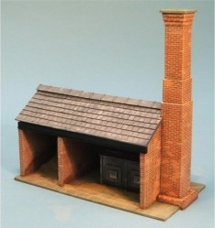The model (see picture) shows how a limited sand plant and chimney were designed, including the furnace to dry the sand and the chimney to remove the noxious fumes.

The plants were sited near to engine sheds, as that is where the sand was needed, to fill the locomotives’ sandboxes. Since the early days of steam locomotives, it has been normal to apply sand to prevent wheels slipping and so aid their adhesion.

Until the end of the regular operation of steam on the Bangor line in 1953, one engine was stabled in the shed overnight, ready to head an early morning train up to Belfast. Hence the need for sand-drying in Bangor.

As the model shows, there are two main parts to the plant – the outbuildings and the chimney. The Bangor chimney stand some 40 feet from ground level, towering by some margin over the Boyne bridge. The outbuildings have had some alteration over the years, being used some decades ago as a facility for milesmen to keep tools in.

At the moment, the source of the bricks for the chimney’s construction is not known, no marking having been found on them. But, it is known from the published reminiscences of Bangor resident William Seyers who, like his father, was a carter for the railway company, that there were several brickyards or fields in Bangor. A prominent one was on Hamilton Road in what is now Ward Park, started by Robert Bowman and then managed by his son James, until its closure in 1906 when the land was acquired by Bangor Urban Council. It is not unlikely that the BHBR, which was not a wealthy company, was content to use bricks made locally for a vernacular building of this nature.

The original Bangor station consisted of a single platform (as shown in the image) although the terminal building was nevertheless described as ‘the most pretentious’ on the BHBR.

Fortunately, there is very clear evidence of the time of construction found in the outbuildings (as shown in the photograph below). Considerable heat was required to dry the sand, and thus bricks that could withstand high temperatures were essential. A survey conducted by Doran Consulting in 2022-23 established the presence of fire bricks made under patent by Robert Brown of Paisley (as shown). This is a vital clue. We know that Robert Brown was joined in the business by his son in 1867 when the firm became Robert Brown and Son. We also know that Brown was advertising in the Belfast newspapers in the early 1860s that at a depot at Queen’s Quay, he had a wide range of bricks for sale including fire bricks, so it seems certain that the outbuildings were erected when the line was first built.

For the first 19 years, the line to Bangor was operated by the BHBR. Although the Company’s engineer provided a formation wide enough for two tracks from the beginning, only one track was laid until the 1890s. The railway historian, Desmond Coakham, recorded in his 2010 book on the BCDR that the BHBR did indeed build a turntable on the Belfast side of the Boyne bridge in what he calls the Bangor Upper Yard, and also the stone engine shed, reached by a single line.

This photograph by Coakham shows the shed, albeit with most of its original roof replaced with asbestos, with the sand chimney visible behind.

However, in 1884, the BCDR effectively swallowed up the smaller and under-capitalised BHBR. The new owners reviewed the assets they had acquired, and as the Company became more profitable over A drawing of a road
the next 30 years, many improvements were made. In particular, the Bangor terminus was enlarged by the Company’s engineer, Culverwell, in 1889/90; Coakham states the original BHBR turntable was removed and two sidings were built by the engine shed; the figure shows the layout in the Upper Yard.

The line from Holywood to Bangor was double tracked in the 1890s.

Edward Patterson in his book, also called *The Belfast and County Down Railway* (1982) states that it was after the BCDR takeover, in 1890 that the terminus was rebuilt and *‘gave the town their first taste of Italianate brickwork and the luxury of three platforms.’* The *Northern Whig,* in an article on 12 February 1891, referred to a turret clock being ordered by the BCDR from Sharman Neill for ‘*the new station at Bangor. This station is certainly one of the most convenient and commodious in the North of Ireland, and this last improvement will be highly popular with travellers’.* Matthew Scott was appointed in 1891 as the stationmaster, serving for 16 years – his obituary noted that he was appointed when the new station was built.

This is a rare photograph of the full length of Bangor station, undated but from the early 20th century, in BCDR days. In the 1950s, after the Ulster Transport Authority took over the BCDR, the station was clad in drab external render. It was demolished in the 1990s.

As noted, one locomotive was regularly kept overnight in the engine shed at Bangor, ready to take one of the first morning trains up to Belfast. Norman Whitla painted a lovely picture of the locomotive which was the usual one shedded at Bangor in his time - No.12 built in 1904 - heading up the bank from Holywood in the 1940s.

Steam was used on the Bangor line up to 1953; in November that year, the Bangor line became the first in the UK to be all diesel.

Neither the shed nor the Bangor sand-drying plant were needed after this point, although there were still occasional steam locomotives at Bangor, as in this 1961 photograph of track being relaid, just before the Boyne Bridge.

The engine shed too has gone, being taken down in the early 2000s to make way for the apartment block that now stands on the site. The splendid signal cabin, on the station side of the Boyne bridge, was abandoned earlier, in 1986.

**Some Notes on Sand Drying**

Why was there a sand-drying plant built beside the Bangor engine shed? Very simply, **t**he provision of dry sand was an important function of all locomotive sheds. Since the early days of steam locomotives, it has been normal to apply sand to the rail head to prevent wheels slipping and so aid their adhesion.

A means was needed to improve the grip of the wheels on the track and a simple solution was found in applying sand between the driving wheels and the rails.  This became part of the firemen’s duties and in the early years of steam locomotives, they would climb down from the engine and apply sand directly to the rails.  As this was inevitably a slow process, it was soon automated so a driver could drop sand directly in front of the wheels via pipes from sandboxes mounted above the wheels.   Gravity fed, the process depended on a supply of dry sand to pass freely through the pipes.  Any sign of dampness and the sand would clog.

One design placed the sandboxes in front of the wheels with a disc valve, rotated by a linkage inside the cab and allowing the sand to fall onto the rail. Problems though were encountered with the disc valves jamming in their gritty environment and the placement of the sand ahead of the wheel meant that strong winds could blow the sand off the rail before the locomotive could effectively make use of it.

In Britain, the Midland Railway introduced in 1886 a system that used compressed air bled from the Westinghouse brake pump to blow the sand under the wheels. The design was adapted to use steam instead of compressed air, and this system was widely adopted throughout the United Kingdom, as shown in the figure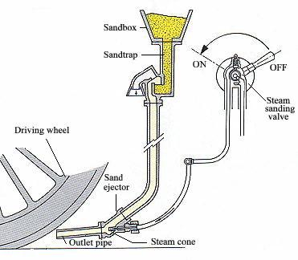.

By way of example, the plant at Rowsley operated with wet sand being shovelled into the top of the furnace out of a wagon on the track next to the sand dryer. There were outlet slots at the bottom of the furnace where the dry sand appeared and was then collected in buckets to fill the sand boxes of locos by the cleaners.

Passengers today might think the track between Bangor and Belfast is smooth and level, in practice there are significant gradients; the steepest is the climb from Holywood towards Marino and on up to Craigavad, but even leaving Bangor there is a slope up to Bangor West. And if the wheels slipped, as they were particularly prone to with leaves on the line in autumn, it posed a major problem for the running of the operation.

The original source of the sand is not known, but it may have come either from the seashore or the old sandpit where Bangor Hospital was later built. That sandpit is mentioned in William Seyers’ recollections. It is known that sand from the local beach was used on the Welsh Talyllyn Railway in its early operating days.

It is important to note that the chimney had nothing to do with letting steam or smoke escape from the engine shed while a locomotive was fired up inside – although close to each other, the two buildings were physically separate.

**The Adjacent Railway Houses at Bangor**

Within 30 yards of the chimney is a row of historic terraced houses, Nos. 2 to 16 Belfast Road, built by the BCDR for workers based at Bangor Station, in the middle of the First World War. It seems likely that the BCDR found that with the increased wartime traffic, (as recorded by Coakham and others), there was a need to ensure that operational staff were to hand at short notice. In fact, from January 1917, the BCDR along with the other private railway companies came under the direction of the Government-created Irish Railway Executive Committee.

The minutes of the BCDR Board, held at PRONI, record the initial decision and then the progress of the project. The chosen contractor was Mr R Hewitt of Bangor, and the agreed price £1495. The minutes tell that the houses were completed and ready for occupation by September 1917.

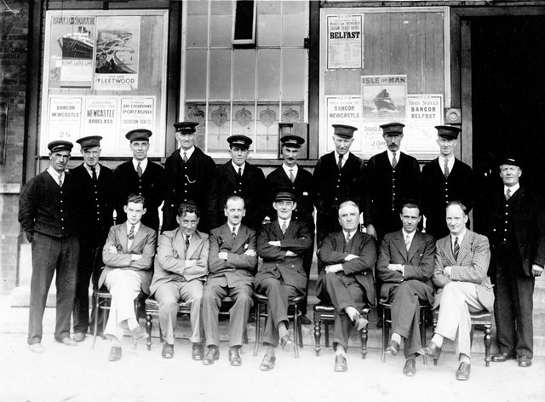This photograph dates from 1935, it shows some of the inhabitants of those houses at the time, clustered round the seated (centre) Bangor stationmaster, Charles Valentine, later the Mayor of Bangor. In the row behind him, for example is James McKee, then a signalman and later himself a stationmaster at Bangor. Mr McKee’s daughter still lives in one of the houses. Other residents of the terrace previously included several women in one house (No. 12) who staffed the bar on the concourse at Bangor station.

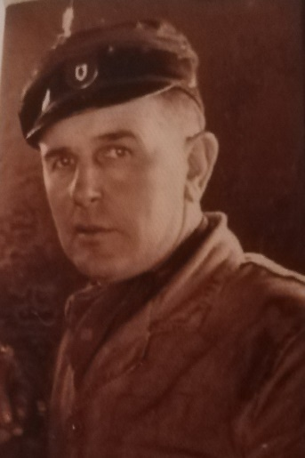BCDR driver Andy Bell (pictured), began his railway career as a fireman. For several years Mr Bell and his family lived in a small railway cottage on the Commons at Donaghadee, and he would drive the 4.30 am goods train to Belfast. When the Donaghadee line closed in April 1950, he was relocated to Bangor Station, to which he had to commute by bicycle; in due course his family moved into a railway house on Belfast Road, where some have resided ever since. His daughter also still resides in one of the houses.

**Bibliography:**

Desmond Coakham, *The Belfast and County Down Railway,* Colourpoint Books, 2010

Edward Patterson, *The Belfast and County Down Railway*, David and Charles, 1982

RM Arnold, *The County Down*, the Last 40 Years, Irish Steam Scene, Whitehead, 1981

Robin Masefield, *Be Careful, Don’t Rush, Celebrating 150 years of Train travel between Holywood and Bangor*, 2015

WA McCutcheon, *The Industrial Archaeology of Northern Ireland*, 1980, and the McCutcheon Archive