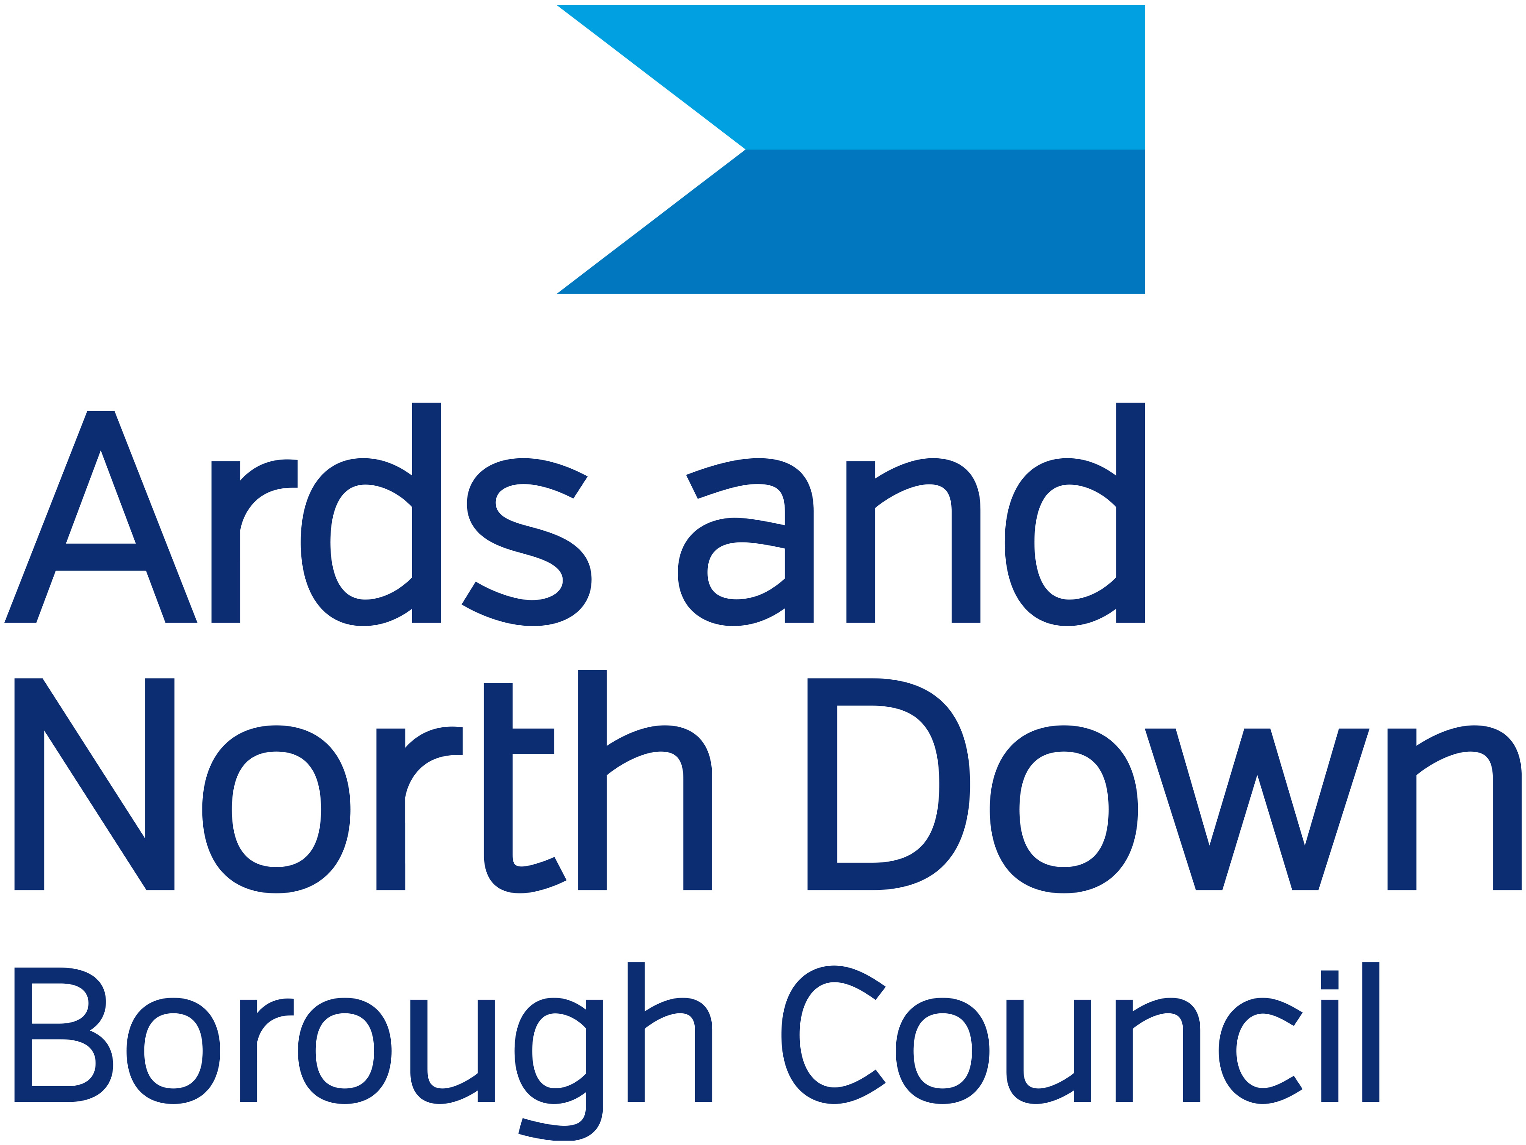

Arts AND Heritage Advisory Panel

Application form 2023
Please refer to the Guidance Notes when completing this form

- Please use CAPITAL LETTERS if using your own handwriting.
- If the form is not fully completed, your application will be invalid.

NAME……………………………………………………………………………………. ……………………………………..

PROFESSIONAL NAME IF DIFFERENT …………………………………………………………………………………..

ADDRESS ……………………………………………………………………………………………………………………...

……………………………………………………………………………………………………………………………………

TELEPHONE ………………………………………… EMAIL ……………………………………………………………..

1. What is your chosen area of experience/expertise? (please ü)

Museums/Heritage
Visual Arts/Crafts
Literature
Performance Based Arts (music, dance, drama etc) Community Arts
Other (please specify)
Additional relevant areas of expertise …………………………………………….

2. To the best of your knowledge do you envisage your involvement with Ards and North Down Borough Council’s Arts and Heritage Advisory Panel to present any conflict of interest?

Yes No

If yes, please specify ………………………………………………………………………………………………

………………………………………………………………………………………………………………………..

………………………………………………………………………………………………………………………..

3. Describe your specialism and/or experience in your chosen area:
(Max 400 words)

4. How do you feel your specialism and/or experience in your chosen area will be of benefit to Ards and North Down Borough Council’s Arts and Heritage Advisory Panel? (Max 400 words):

5. Name, address and phone number of 2 Independent Referees who have knowledge of your experience or expertise.

Referee(1) Referee(2)
Name______________________ Name_________________________

Address____________________ Address_______________________

___________________________ _____________________________

___________________________ _____________________________

Tel: _________________________Tel:__________________________

6. APPLICANT’S STATEMENT

I have completed all relevant sections of this application form and confirm that all information provided is truthful and accurate.

Signed: _________________________________________________
(The applicant)

Date: _________________________________________________

APPLICATION DEADLINE: Friday 21 July 2023 at 12 noon
Should it be deemed necessary, interviews will be held on Friday 28 August 2023

COMPLETED APPLICATIONS

Return by email to: arts@ardsandnorthdown.gov.uk

Or by post to:

Ards Arts Centre or North Down Museum
Town Hall Town Hall
Conway Square The Castle
Newtownards Bangor
BT23 4NP BT20 4BT

FOR ENQUIRIES:
Emily Crawford, Arts and Heritage Manager: 028 9181 0803

