CommmunityNI Venues Directory on CommunityNI

Background
Following on from discussion around next phase of communityni development with Feargal and Kevin (BT48) on tues 08/12/20 to agree way forward in relation to the draft Communityni Development Sprint doc created 02/12/20
Discussed how to prioritise work to enable getting Venue directory up and running by end Jan. Other interim solutions for work in the doc such as Organisations ownership and API have been sorted with a view to focusing on the venue directory up to end Jan deadline.
Agreement is that the best way for NICVA to work in partnership with BT48 to deliver venue directory feature by deadline is to do the wireframes and thinking around user journeys, micro messaging etc to allow BT48 to focus on build and move to production.
The intention is to use existing concepts, workflows, and page elements and to keep focused on a minimal viable product ready for promotional campaign starting at end of January 2021. The promotional campaign call to action will be to ask organisations to add their venue offerings on the site.

Aims
Provide a venue directory to allow VCSE organisations to advertise their venue offerings. The directory should have a proximity/location search similar to Services entity search. Each organisation can have one or more venue listing to cater for multiple locations/venue offerings. Offerings could might include thing like community halls, conference and meeting rooms, residential, Office rentals. Organisations should be able to add/edit venue nodes in same way they can add services, jobs etc via the user dashboard.
The table below sets out sketches for elements needed. Generally taking an existing layout/concept and adapting in first column. Second column includes sketch with blue blocks to show adaptations which are numbered with corresponding notes in column three.
Sketches intended to help make quick decisions. Some options are included.
Would it be useful to consider three sprints for the work to be done?
- features ready for end Jan launch of Beta Venue Directory (sprint one).
- structured user testing programme (say 15 users) and bug fixes (sprint two - Feb)
- final sprint with results of user testing and any current & emerging issues (sprint three March)

(1) Home Page | www.communityni.org
Based on | New Elements | Notes
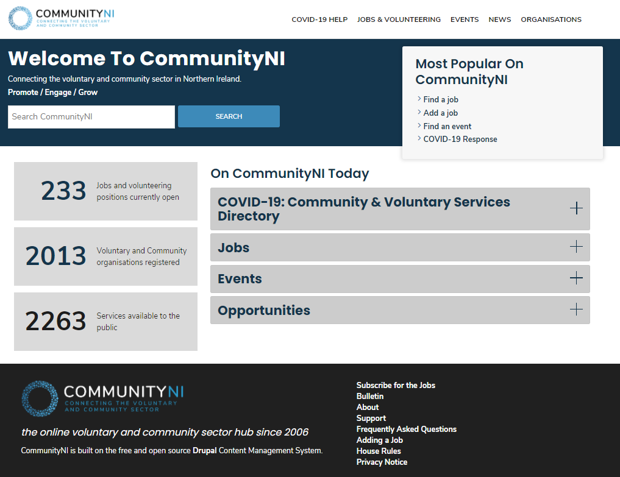 | 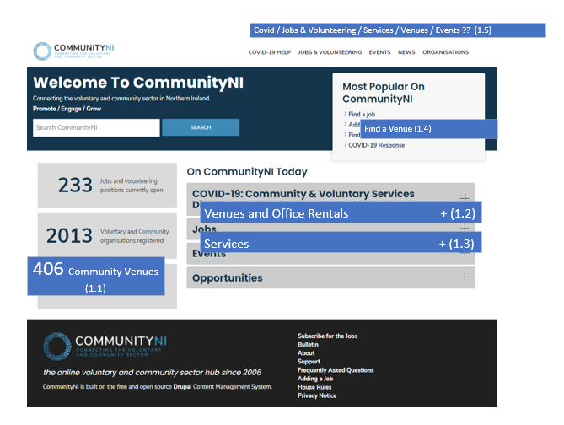 | - – Block with total of Venue nodes  - – Accordion Block with same approach as others – “ Venues & Office rentals” - options are (1) Search for a venue (leads to /venues home page) or (2) add a venue leads to sign in or straight to user dashboard  - - Accordion Block with same approach as others – “ Services” - options are (1) Search for a service (leads to /services home page) or (2) add a service - sign in or straight to user dashboard  - Replace find an event with find a venue  - Decide on menu items – perhaps as shown
(2a) Venue Home page (OPTION 1) | www.communityni.org/venues
Using /jobs as template  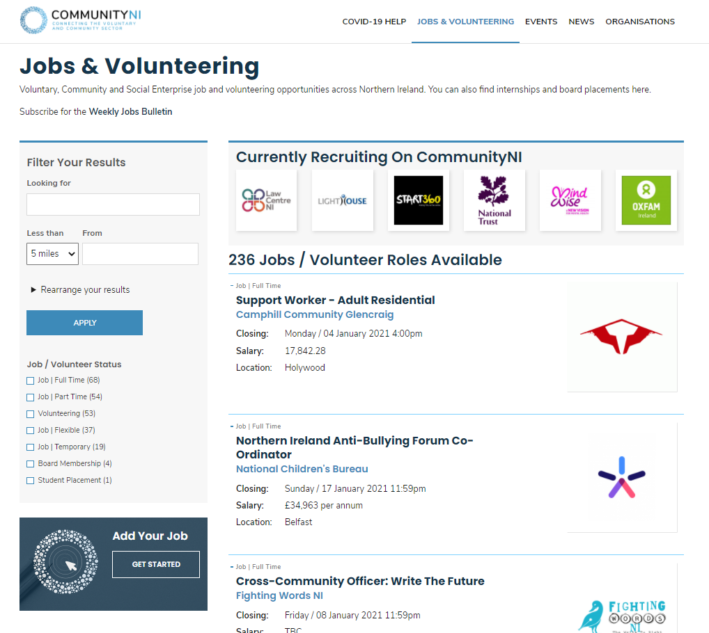 | Venue Nodes Home Page / Search  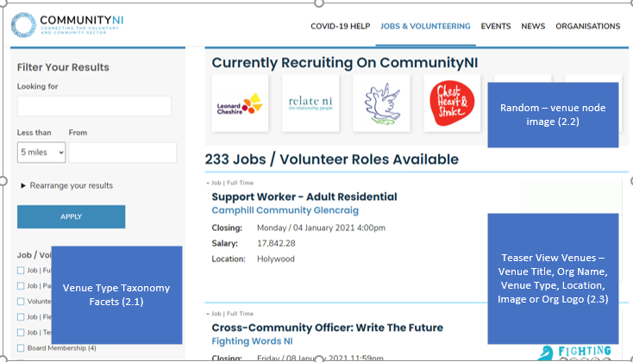  Add your Venue Promo block (2.4) | Venue nodes search  - Venue Type Taxonomy facets including Community Hall, Conference & Meetings Rooms, Office Space rental, Residential  - Either org Logos or Venue Node Image. Venue node image might encourage orgs to add decent venue images.  - Teaser view with similar format to jobs – Title, Organisation, Venue type, location & Org Logo/Venue Image  - Promo block for add your venue  Issues: no map
(2b) Venue Home page (OPTION 2) | www.communityni.org/venues
Use covid search page  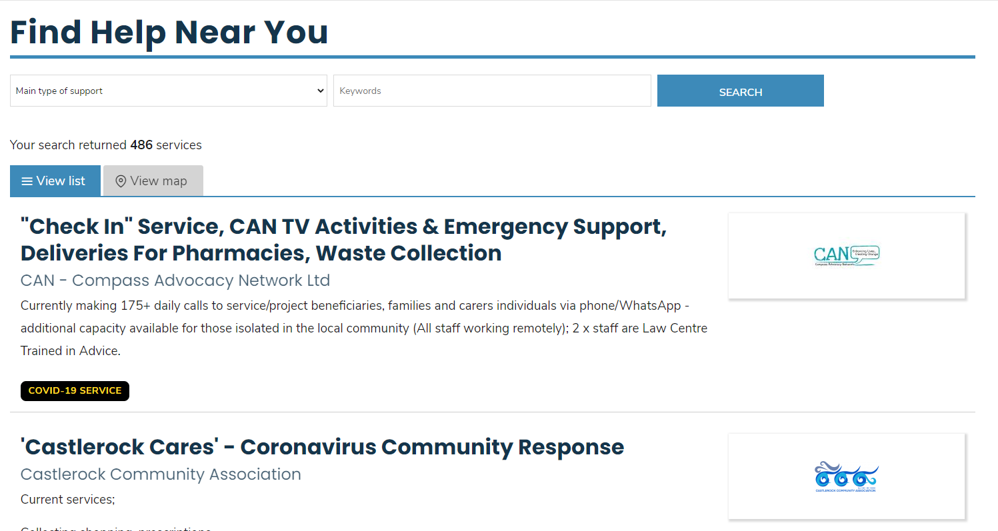 | 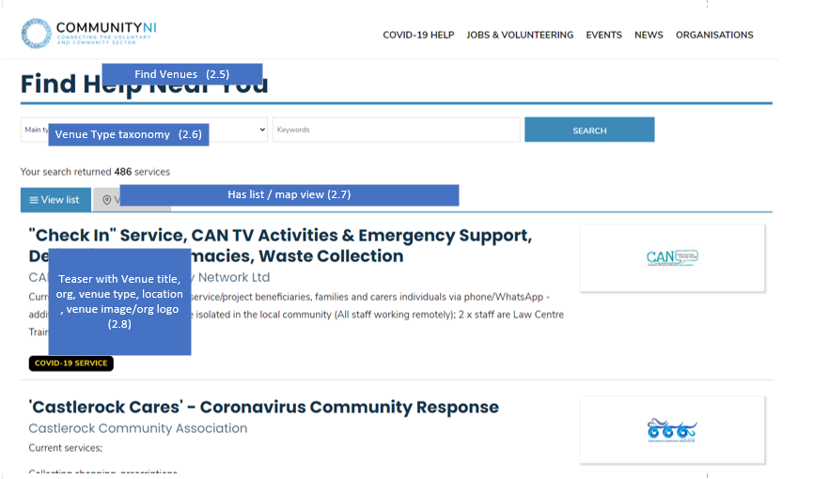 | 2.5 – Page title: Find Venues or Office Rentals  2.6 – Include Venue type taxonomy as search facet  -  2.7 - This option has the View List / Map View as an option  - 2.8 - Teaser list as set out

(3)Venue Node View Page | www.communityni.org/venue/[NODE_TITLE]
Based on Service node layout  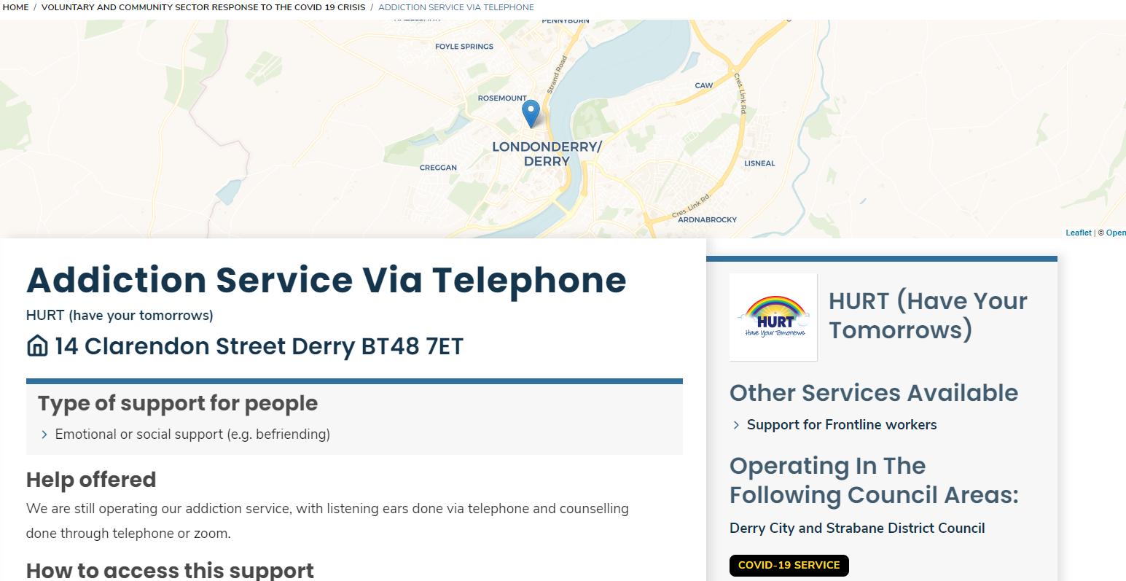 | 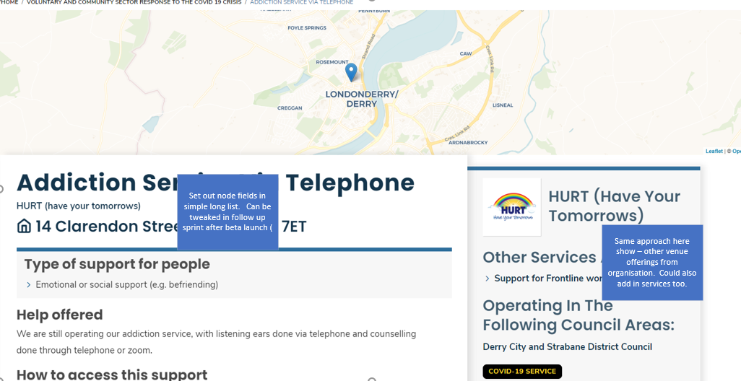 | - Map in header  - Set out fields in list – similar approach to service nodes. Refine order / styling in Sprint 2 feb after beta user testing.  - Use same approach as services for right sidebar – show other venue offerings and perhaps include services the org provides as well.  - Draft fields in appendix 1
(4) Venue Node Edit page  Beta to have all fields grouped in field sets and ideally help / guidance text where needed | Draft fields in appendix 1
(5) User Dashboard
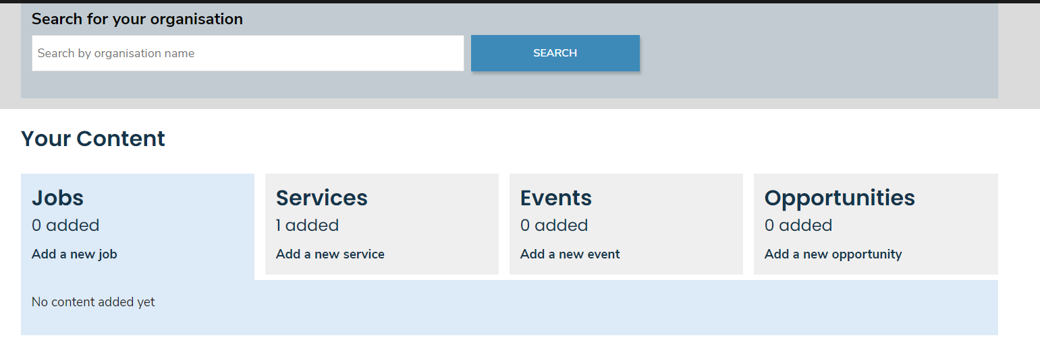 | 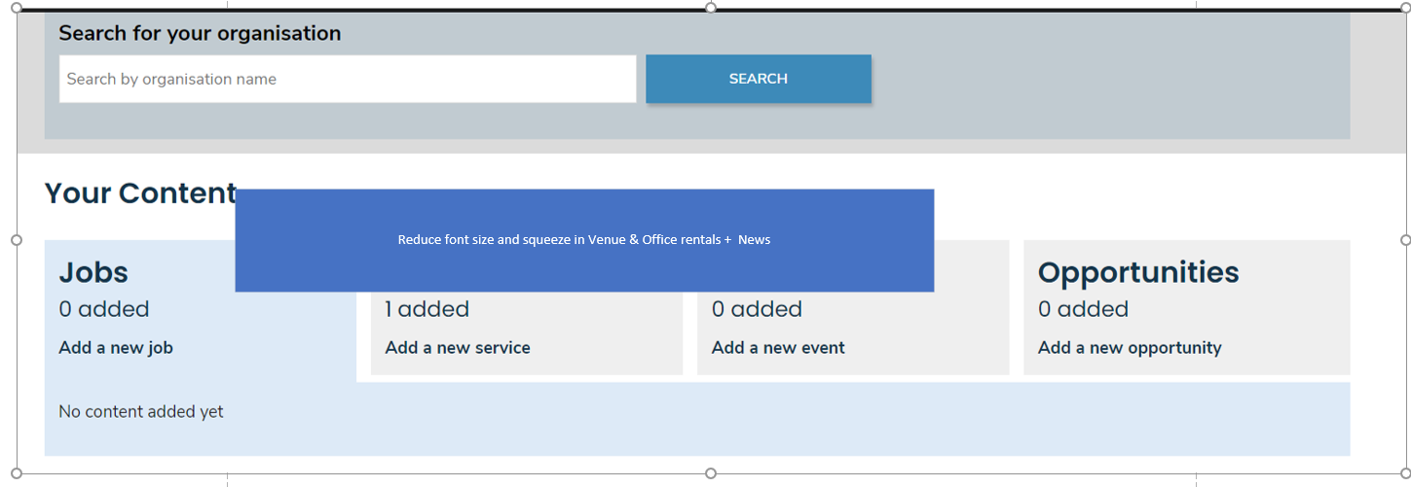 | - Reduce font size of “tabs” and squeeze in Venue & Office rentals + News?  - If not possible any other visual device?  - Make add a new [node] link more obv a link / button  - Views showing corresponding nodes as with jobs / services

Appendix 1
Field Set | Field Label | Machine Name | Help text | Note / example
Venue Summary | Venue Title | venue_title | Title of your venue for search results and listings | NICVA Conference Rooms and Office Rentals
 | Description | venue_description | Give an overview of your rental offering. for example for Room Hire include capacities, layout options. For Office rentals include options available. | Range of meeting and conference rooms for up to 150 people.  Flexible options on Office Space rental
 | Location | venue_location | Full Address of your venue | Include postcode and process to complete other Admin Boundary fields
 | Accessibility Provision | Venue_accessibility | Description of accessibility features eg physical access, hearing loops, reserved parking
 | Social Distancing Measures | Social_distancing_measures | Description
 | Costs | venue_costs | An overview of costs associated with your venue offering | Textbox as could contain wide variety of info from rental , room hire, catering, equipment etc.
 | Venue Type(s) | venue_types | Choose from the list | taxonomy to include eg community hall, conference rooms & meeting rooms, Office rental, Residential
Venue Contact | Contact Instructions | venue_contact_instructions | How should people contact you about the venue. You could Include named people, telephone numbers, times etc. | Contact us 9-5 Mon to Fri.  For Room Hire call Paula Fitzpatrick or email bookings@nicva.org  For Office rentals call Una McKernan or via www.nicva.org/support
 | More Information Link | venue_url | Link to more information about your venue, booking instructions etc | https://www.nicva.org/venue-hire/conference-facilities
 | Contact Phone | venue_contact_phone | Venue Contact number
 | Contact Email | venue_contact_email | email address
Venue Facilities | Parking | venue_parking
 | Equipment | venue_equipment
 | Catering Options | venue_catering | Overview of options for event catering
Policies and Health & Safety | Social Distancing / Hygiene Measures | venue_distancing | Description of measures in place to enable social distancing and compliance with regulatory guidance
 | Booking Policy | venue_bookingpolicy
 | Cancellation Policy | venue_cancellationpolicy
Venue Image(s) | Venue Image field

